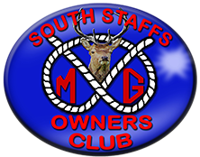
Hammerwich Classic Car Show
Hammerwich Cricket Club, Burntwood Road, Hammerwich,
WS7 0JQ

Event number: 290924
Date: Sunday 29th September 2024
Meeting place: Tesco, Brownhills, WS8 6DZ
Time: 09:00am
Booking cut-off date: N/A
Cost: Free. A charitable donation is requested
Event organiser / contact: Mick Harper

Additional Information: The club-house will be open for the use of toilets and bar. I have spoken to the organisers and they will allow our newer MG’s. Please let Mick know if you wish to attend.

Details: This is a classic car show for all TAX-EXEMPT historic vehicles over 40 years old. Absolutely no formalities, simply turn up in your veteran/vintage/classic car and park next to many others.

