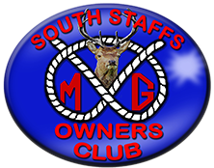
“The Navigation to
Lapworth Run”

Event number: 061024
Date: Sunday 6th October 2024
Meeting place: Bassets Pole, McDonalds, B75 5SA
Time: TBA
Booking cut-off date: 22nd Sep 2024
Cost: As per menu
Event organiser / contact Nigel Preston (07743 012 165)

Details: SSMGOC members & friends welcome for a app 36 mile run through some lovely lanes ending with a yummy dinner, wine & ales! Fingers crossed for late summer sun. Menu available soon.

To secure your booking, a £10 per person deposit is required please.

