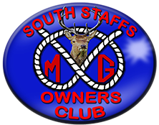
The National Tramway Museum
Crich Tramway Village, nr Matlock,
Derbyshire, DE4 5DP

Event number: 020624
Date: Sunday 2nd June 2024
Time: 08:30am
Booking cut-off date: TBA
Meeting place: David Lloyd car park, Wall Island, WS14 0QP
Cost See below
Event organiser / contact: Mick Harper

Additional Information:
*Entrance fees: Adult and seniors £23.00 including free return within 12 months
Child (aged 4 – 15) £14.00
For our visit the driver is free of charge

Details: The National Tramway Museum have given our club special permission to park within the Tramway Village so our cars will be on display to members of the general public who are visiting the museum. Our cars need to remain in the village for at least 3 hours and the driver is admitted free of charge.

The Tramway Museum is packed with activities to keep you occupied all day. Several trams will be running and the return trip takes 20 – 25 minutes, ride as many times as you want during the day. Wander around the period village, stop at the Red Lion pub, relax in Rita’s Tea Room and don’t forget to visit the Ice-cream Parlour. There is also the tram depot and shops.

Please let Mick know if you wish to attend.

